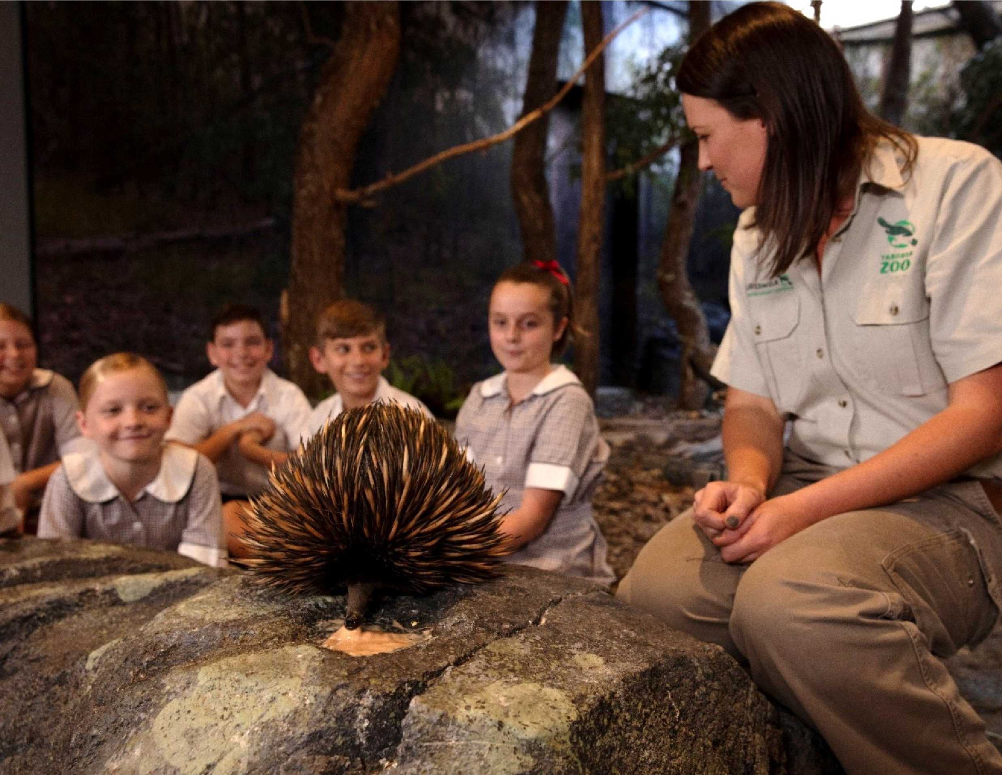

**Contents**

MAKING A BOOKING 3

PAYMENTS 3

REFUNDS 4

CANCELLATIOINS AND POSTPONING 5

TRANSPORT OPTIONS 5

COACH 5

FERRY 5

PUBLIC BUS 6

TARONGA CAR PARK 6

MORE TRANSPORT INFORMATION 6

PLANNING YOUR DAY AT TARONGA 7

MAPS 7

PRESENTATIONS, KEEPER TALKS AND CLOSURES 7

WAYFINDING 8

SUGGESTED TRAILS AND WALKS 9

KIDS TRAIL (YEAR K-2) 11

AMAZING AUSSIE ANIMALS (YEARS 3-4) 11

WILDLIFE CONSERVATION – TARONGA’S LEGACY SPECIES (YEAR 5-6) 12

CLASSIFICATION AND ADAPTATION (YEAR 7-8) 12

FINAL CHECKLIST 12

SELF-GUIDE/WORKSHOP EXCUSION TEMPLATE 12

TARONGA WILD SQUAD 13

CAMPAIGNS -ACT FOR THE WILD 13

FREQUENTLY ASKED QUESTIONS 14

LOST CHILD PROCEDURES 14

FIRST AID 14

ACCESSIBILITY AND MOBILITY 15

LUNCH LOCATIONS 15

Next Day Lunch Packs 16

WET WEATHER AND EXTREME WEATHER PLANS 16

MORE GREAT OPTIONS AT THE ZOO 16

DIGITAL PROGRAMS 17

STAY CONNECTED 17

# Making a Booking

Have a look at the [different options](https://taronga.org.au/education/school-workshops-sydney)available for your visit (self-guide, workshop or full day program). If you have any questions about your options, please call 9978 4578.

Once you are ready to book, please ensure you complete a booking inquiry via our [Self Guide](https://selfguided.taronga.org.au/School/sydney?_gl=1*lf77p9*_gcl_au*MTE1MTQ3MjUyMi4xNzM3NDEzNjQ4*_ga*NzAxNjg2NTU3LjE2Mzc4ODc3Mjg.*_ga_GFFRJH34TQ*MTc0NDY4OTY3OS4xMy4xLjE3NDQ2ODk3ODYuMTMuMC4w) booking form or our [Workshop](https://taronga.tfaforms.net/15) booking form[.](https://taronga.org.au/education/excursions/book) Your request comes through to the Education Team who will you will hear back from via email with confirmation details or alternate options.

# Payment

Taronga Zoo has thousands of school visitors every year, so to ensure your school is not delayed unnecessarily all education excursions must be **PRE-PAID.** Entry may be refused if payment has not been received prior to your visit. **Please pass your invoice to your accounts department or SAM for processing.**

**Unsure how many students you will have?**

We recommend booking an excursion for the maximum number of students you are likely to bring. You can call or email before your visit to amend your booking. On the day of your visit, you will be asked to sign in for the number of students you have brought – if there are less students, a refund can be organised **post-visit**. If you have brought more students, the balance of the payment must be made at the ticketing desk before entering the Zoo.

**PAYMENT METHODS:**

**PREFERRED METHOD - Credit Card (payment can be made up until the morning of your** excursion)

To make payment via credit card please call education on ph: 02 9960 9907 or send an email with your contact details and we can call back to take payment. Visa, Mastercard and American Express are accepted.

**PREFERRED METHOD - Direct Deposit (2 weeks before your excursion)**

**Account Name:** Taronga Conservation Society Australia

**Bank:** ANZ

**Branch:** Mosman

**BSB:** 012 351

**Account Number:** 775406049

**Reference: Tax Invoice or booking number**

Please send your remittance advice to education@zoo.nsw.gov.au

**NSW Department of Education – LMBR/ Shared Services Payments**

Department of Education schools can make payment via **Purchase Card** over the phone by contacting the education team on ph: 02 9978 4578 or send us an email with your contact details and we can call you back to take payment. After consultation with the Department of Education, **Shared Services have recommended Purchase Cards as the preferred method for pre-payment**.

If you do not have access to a PCard, you will need to create a free text shopping cart and follow the steps below.

1. Create a free text shopping cart using the information provided on the Pro-forma invoice sent with your booking confirmation.

**Vendor ID:** 100024034

**ABN:** 41 733 619 876

1. Confirm the Purchase Order
2. Download and complete the ‘[Pre-payment request form’](https://cms.det.nsw.edu.au/sap-finance/downloads/accounts-payable/forms/sch-requestprepaymt.pdf)

**BSB:** 012 351

**Account Number:** 775406049

1. Email the completed and signed form to

EDConnect.accounspayable.schools@det.nsw.edu.au at least 5 days prior to the date of your visit.

1. Email Taronga education with your purchase order and confirmation numbers.

## Refunds

Refunds can be organised for applicable bookings after your excursion date. Please contact education@zoo.nsw.gov.au to discuss further.

## Cancellations and Postponing

Please let us know by return e-mail (education@zoo.nsw.gov.au) if you need to cancel your excursion. If it is within 48 hours please call education on 02 9960 9907.

If you do not show up for an excursion and you have not sent us an e-mail confirming cancellation, you will be charged.

# Transport Options

## Coach

**Coach parking is located on Bradley Head Road, northbound immediately before the bus bays. This is shown on the map in purple. Parking is available on a first come first served basis and cannot be reserved.**

Where possible we recommend using the outermost drop off and pick up bay on Bradleys Head Road. Private coaches are not permitted to use the Transport NSW bus bays indicated in red, only the bay closest to the road, shown in blue.

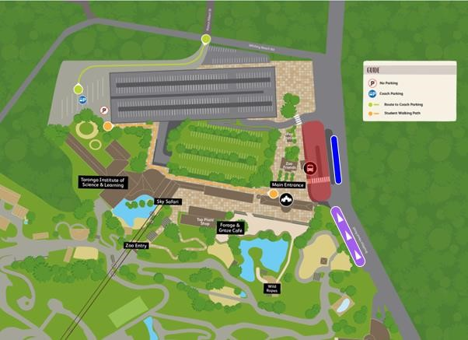

## Ferry

Transport NSW have a ferry service which runs from Circular Quay to Taronga Zoo Wharf every half hour.

**Please note students will need separate tickets, Opal cards, or bank cards to tap on/off to use the service.** These ferries are run by Transport NSW and therefore no combination deals for Taronga Zoo entry and ferry tickets are available.

**For timetable and fares, please visit information:** [**https://transportnsw.info**](https://transportnsw.info/)

**Entry to the Zoo:**

You will need to catch a connecting Transport NSW bus to the Main Entrance of Taronga Zoo. You will need to purchase a ticket for this or use Opal cards, which adds a transfer from the ferry service.

For large groups, admission onto the bus is per the discretion of the Transport NSW bus driver. Otherwise, you can contact the Education team who may be able to coordinate group entry through the lower Zoo entrance/exit if staff are available.

## Public Bus

Transport NSW buses run to Taronga Zoo from the City, Balmoral Beach, and Milsons Point.

**Bus Routes:**

100 – City (QVB and Wynyard) to Taronga Zoo

228 – Milsons Point to Clifton Gardens

238 – Balmoral Beach to Taronga Zoo and Taronga Zoo Wharf

**Please note students will need separate tickets or Opal cards to use the service.** These buses are run by Transport NSW and therefore no combination deals for Taronga Zoo entry and bus tickets are available. For large groups using public transport, admission onto the bus is at the discretion of the Transport NSW bus driver.

**For timetables and fares, please visit information:** [**https://transportnsw.info**](https://transportnsw.info/)

## Taronga Car Park

Parking for cars is available at the Zoo. Entry to the car park is from Bradleys Head Road and the day rate is $24.

## More Transport Information

Please see our website: <https://taronga.org.au/sydney-zoo/getting-here>

# PLANNING YOUR DAY AT TARONGA

## MAPS

Do you have a map and know where you are going? Our advice is to be flexible, but have a few key experiences to see. It is Taronga Zoo policy in the interest of sustainability and waste minimisation that printed materials are only handed out in limited quantities. **We cannot give every student a map during their visit.**



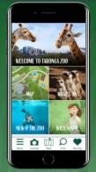We advised you to [download or print a map from our website,](https://taronga.org.au/sydney-zoo/visitor-information#zoomap) or try the [Taronga App for iPhone and Android Devices.](https://taronga.org.au/sydney-zoo/app)

Available for Android and Apple devices, the Taronga App helps you plan your day more efficiently with real time information on maps, presentations, keeper talks, event capacity, closures and works.

Stay up to date and download it today from [https://taronga.org.au/sydneyzoo/app](https://taronga.org.au/sydney-zoo/app)

## PRESENTATIONS, ZOOKEPPER TALKS AND CLOSURES

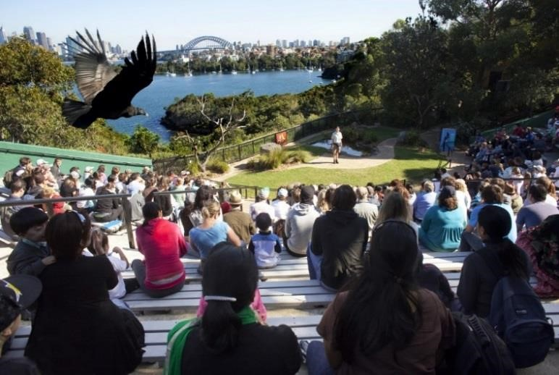

A Zoo is a constantly changing environment and animal welfare is a priority for Taronga. Animals may be affected by weather, illness, or sometimes just having a quiet day. Our wildlife teams monitor these situations closely and may make last minute decisions regarding what animals are on display within the Zoo and when keeper presentations and shows will go ahead.

The Guest Experience staff will update signage and may make announcements regarding closures or cancellations via the P.A system, so listen closely. Check with the Information Desk on the day of your visit for the most up to date information and tips for what to see (e.g. baby animals, feeding times, etc.) or download the Taronga App for real time updates.

**Seals for the Wild Presentation times**: Everyday at 11am and 2pm

**Free Flight Birds Presentation times**: Everyday 12pm and 3pm

**For other keeper talk times**, visit: [https://taronga.org.au/sydney-zoo/shows-and-keepertalks](https://taronga.org.au/sydney-zoo/shows-and-keeper-talks)

To avoid disappointment on the day, make sure you’re informed of [closures and works](https://taronga.org.au/sydney-zoo/visitor-information/closures-and-works) occurring at the Zoo.

## WAYFINDING

**Familiar exhibits and landmarks may have moved from previous visits**, so please make sure to check the [website](https://taronga.org.au/sites/default/files/2020-12/TZMap_Ed12v01.pdf) for our most up to date information.

***Please check your confirmation email for information on*** [***workshop locations***](https://taronga.org.au/education/excursions/learning-spaces) ***and meeting points.***

**Taronga Institute of Science and Learning (map ref. L9)**

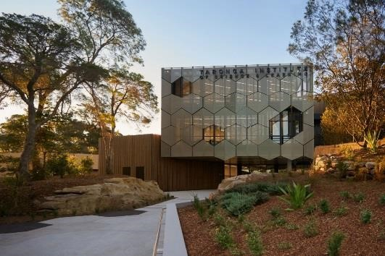

**Backyard to Bush House (map ref. E4) Farm (map ref. C3)**

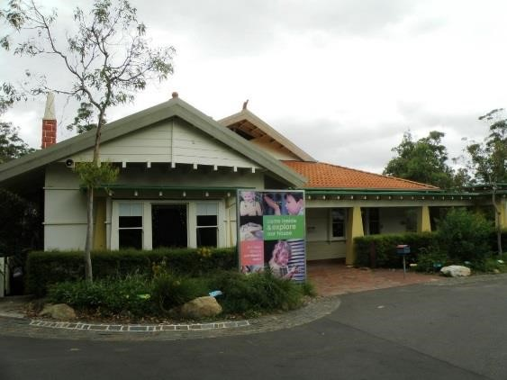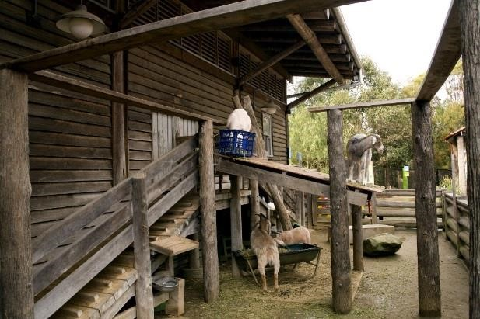

## SUGGESTED TRAILS AND WALKS

Once you have your [map,](https://taronga.org.au/sites/default/files/2020-12/TZMap_Ed12v01.pdf) take a look at [What’s On at Taronga t](https://taronga.org.au/sydney-zoo/whats-on)o help you organise your day. Below are some suggested activities – choose the best to suit your students and outcomes for the day.

|  |  |  |  |
| --- | --- | --- | --- |
| **Time** | **Activity** | **Location** | **Notes** |
| **10am** | Arrival | Top Plaza | On arrival make sure to sign in at ticketing before proceeding into the Zoo.  Now’s a good time for a quick bathroom stop! Map Ref (L6) |
| **10.30 AM**  **11.30 AM**  **12.30 PM** | Zoo Education  Workshop Times  (Set Times,  Prebooked) | See Invoice for details on meeting location | If you’ve booked in for a workshop, please proceed to your meeting locations where your Zoo teacher will meet you. |
| **OPEN ALL DAY**    (estimated time 5mins) | Capybaras | Map Ref I9 | Introducing the largest living rodent in the world! Capybaras are related to the guinea pig. They are a semi-aquatic mammal with webbed feet and can dive and stay underwater for up to five minutes at a time. They can also reach speeds of up to 35km/hr on land! |

|  |  |  |  |
| --- | --- | --- | --- |
| **11 am** (also at 2pm) | Seals for the Wild | Map Ref F9 | Enjoy morning tea at this favourite of Zoo visitors young and old. Showcasing training and behavioural conditioning by our marine team, learn about the importance of sustainable fishing and actions we can take to keep our oceans beautiful for both humans and the wild. |
| **OPEN ALL DAY**  (estimated time  20mins) | Rainforest Trail | Map Ref F13 | Take a walk around our  Rainforest Trail and see some of the endangered animals from our closest Asian-Pacific neighbours. |
| **12.00pm** (also at 3pm) | Free Flight  Birds  Presentation | Map Ref G16 | With the stunning view of Sydney  Harbour as a backdrop, Free Flight Birds introduces you to some of the amazing birds of Australia and their unique talents. Be amazed as they soar overhead! A must see. |
| **12.30pm** | Lunch Time |  | Suggested locations include:  Concert Lawns (Map Ref D5) or other lawn areas (Map ref G15, F4, I8) |
| **OPEN ALL DAY**    (estimated time 20 mins) | African Savannah | (Starts)Map Ref J13 | Immerse yourself in the sights and sounds of Northern Kenya as you experience this multispecies exhibit. Learn about the lives of a Kenyan family, working to protect wildlife, generate income from artisan beadmaking, and attending school! |
| **OPEN ALL DAY**  (estimated time 20 mins) | Tiger Trek | Map Ref G14 | Board a flight to Sumatra and be transported to Way Kambas National Park to see the magnificent Sumatran Tiger. Explore the village, and discover how we all have a role to play in saving this Critically Endangered species from extinction. |
| **OPEN ALL DAY** | Backyard to Bush | Map Ref E4 | The Backyard to Bush precinct takes you from the urban to rural then bush environments. Introduce students to common backyard buddies, farm yard animals and Aussie favourites.  Great for ES1 and S1 students. |
| **OPEN ALL DAY** | Blue Mountains Bush Walk | Map Ref H6 | Immerse yourself in a pocket of the Blue Mountains transported to Sydney. Meet flora and fauna native to this area including wallabies, regent honeyeaters and the pre-historic Wollemi Pine. Keep a look out for the elusive platypus! |

## KIDS TRAIL (YEAR K-2)

1. Backyard to Bush House – Reptiles and Invertebrates (E4)
2. Rabbits and Guinea Pigs (D3)
3. Farm Yard (C3)
4. Australian Bush (B2)
5. Bush Theatre – Enjoy the view! (C5)

## AMAZING AUSSIE ANIMALS (YEARS 3-4)

1. Koala (K11)
2. Australian Rainforest Aviary (J7)
3. Platypus (J4)
4. Wombat (J4)
5. Kangaroo Walkabout (K4)
6. Southern Cassowary (I7)
7. Blue Mountains Bush Walk (H6)
8. Backyard to Bush (E4)
9. Saltwater Crocodile (G7)

## WILDLIFE CONSERVATION – TARONGA’S LEGACY SPECIES (YEAR 5-6)

1. Centenary Theatre (I12)
2. Southern Corroboree Frog (K12)
3. Sumatran Tiger (G14)
4. Sun Bear (G14)
5. Regent Honey Eater (H6)
6. Platypus (J4/I4)
7. Bilby (J4)

## CLASSIFICATION AND ADAPTATION (YEAR 7-8)

1. Reptile World (L13)
2. Chimpanzees (K13)
3. Giraffe (I13)
4. Great Southern Oceans and Seal Show (F9)
5. Blue Mountains Bushwalk (H6)
6. Platypus (J4)
7. Kangaroo walkabout (K5)

## FINAL CHECKLIST

Before you visit, please familiarise yourself with our [important updates](https://taronga.org.au/news)page. Upon arrival at Taronga Zoo you will be required to **sign for the exact amount of students/adults you have with you. Either do this with the Education volunteer at the top entrance or sign in at ticketing.** Check the times of any keeper talks and shows you wish to attend. Changes to daily schedule can be found on our website and at the information desk.

If you have booked an education workshop, make sure your group knows where to go and at what time. Use the planning sheet below to help.

## SELF-GUIDE/WORKSHOP EXCUSION TEMPLATE

To help communicate to your other teachers and parent helpers, use this template to personalise the details of your visit below.

Group #: ______________________

Emergency Contact Details:

* Name #1: __________________ Phone number: ______________

* Name #2: ___________________ Phone number: _______________

Workshop Time (if applicable): ___________________________

Workshop Location (if applicable): ____________________________

Post-Workshop Meeting Location (if applicable): _____________________________

Lunch Location: ____________________________________________

## TARONGA WILD SQUAD

Taronga is committed to doing great things in conservation. [Become a Wild Squad Agent](https://taronga.org.au/sydney-zoo/must-see/wild-squad) and be the change For the Wild! [Download the app](https://taronga.org.au/sydney-zoo/app) to:

* Browse the interactive map for easy navigation and directions around the Zoo
* See up-to-date information for everything that's on today at the Zoo including opening hours, animal talks, shows and encounters
* Discover Wild Squad Missions for kids through a series of fun, quick and interactive missions that will help kids learn more about conservation and the animals they are seeing at the Zoo

## CAMPAIGNS - ACT FOR THE WILD

Before your visit, read about what you can to do influence a change for good. Some of these involve actions you can do before and after your visit.

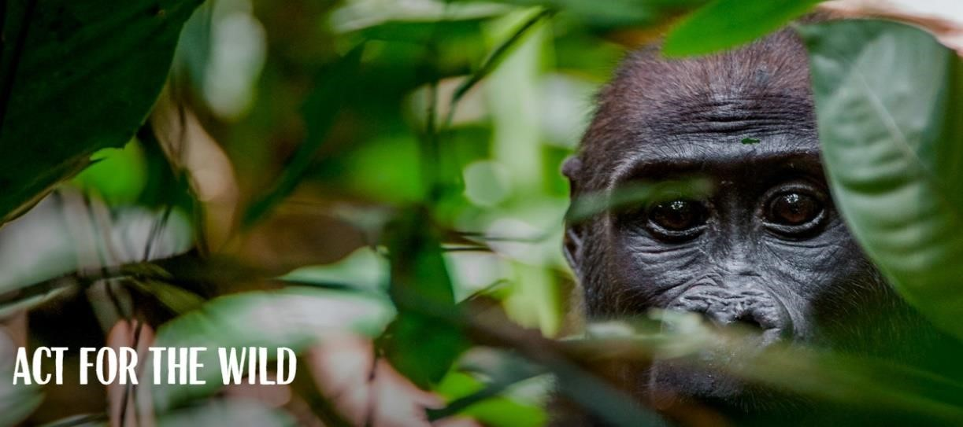

* [Litter Free Oceans](https://taronga.org.au/litter-free-oceans/) – Single use plastic greatly impacts marine wildlife. Calculate the positive impact you can make on our oceans by switching to reusable items.
* [Litter Free Rivers](https://taronga.org.au/sites/default/files/content/pdf/LitterFreeRivers_Toolkit_Schools.pdf) – Our freshwater systems are experiencing a serious threat. Learn how your school can create a world of change for the platypus and our rivers.
* [Raise Your Palm](https://taronga.org.au/conservation-and-science/act-for-the-wild/raise-your-palm) - We celebrate companies that use Certified Sustainable Palm Oil. The more companies transform their supply chain, the more we can enjoy products free from deforestation.
* [They’re Calling on You](https://taronga.org.au/conservation-and-science/act-for-the-wild/theyre-calling-on-you) – All four subspecies of gorillas are now critically endangered. Recycle your old mobile phone to help protect them.
* [Fish For Good](https://taronga.org.au/conservation-and-science/act-for-the-wild/fish-for-good) – There are simply not enough fish in the sea. By choosing seafood with the blue MSC label you can support independently certified and sustainable fisheries.
* [Beads for Wildlife](https://taronga.org.au/conservation-and-science/act-for-the-wild/beads-for-wildlife) – We need to find a way for humans and wildlife to coexist, and the solution lies within communities. Support women in northern Kenya with a wildlife-friendly source of income.
* ReWiild your Life– As our cities expand, our local wildlife's habitat is beginning to shrink. You can help ensure we have forests for the future by choosing Forest Stewardship Certified (FSC) certified timber and paper products.
* [Climate Heroes](https://taronga.org.au/conservation-and-science/act-for-the-wild/climate-heroes)– Learn to live like an amphibian or reptile and help fight climate change. If us humans lived a little more like amphibians and reptiles, it would have a major impact on the planet.

# FREQUENTLY ASKED QUESTIONS

## LOST CHILD PROCEDURES

The Zoo can be a very busy place, and it is not hard to lose sight of a child during your visit! To help minimise the risk of lost students please ensure the supervising adults have arranged regular roll calls, emergency meetings points and student identification and contact information as relevant for the age and needs of students.

If a child is lost during your excursion, please visit any Taronga Staff member in grounds. They will activate our lost child procedures and all staff in-grounds will be notified.

Students should be advised to approach a Taronga Staff member (in uniform) if they should become separated from their group.

## FIRST AID

For Schools visiting Taronga Zoo, the duty of care responsibility is on the teachers supervising the excursion. Schools must bring their own first aid kits. Supervising teachers should also have with them any relevant student medical information and emergency response plans for anaphylaxis, asthma and other medical needs. Teachers should also be aware of any medication required by students including EpiPens and asthma treatment.

If assistance is required, Taronga has a well-equipped First Aid Centre and a large number of trained First Aid Officers. Contact the Information Centre, any employee or food outlet staff for assistance in case of an emergency.

## ACCESSIBILITY AND MOBILITY

Taronga Zoo is on a site of 28 hectares and the topography is quite steep in some areas. Although all paths are bitumen and lateral paths relatively level, some connecting paths linking various levels are steep. For this reason, a good level of fitness is required by supervising adults.

For students or adults who require them, elevators and ramps are located around the site, allowing all to traverse the entire Zoo. These are indicated on the Zoo map. More information on accessibility including a map can be found [here.](https://taronga.org.au/sydney-zoo/accessibility)

Majority of Taronga’s animal displays are wheelchair viewable. All food outlets, shops, shows and presentations are wheelchair accessible. All new developments since 2001 have been fitted with elevators.

Manual wheelchair hire is available at no cost to those who require mobility assistance (ID required) and a disclaimer form must be completed. **These wheelchairs must be pushed by a carer/companion and seat belts are required to be worn.** Advanced booking is recommended (02 9960 9907). Wheelchairs may be hired from the ‘Top Plaza Shop’ (map reference L7).

Taronga also has an accessible bathroom for use by all guests and students issued with an MLAK Key. This amenities facility is located centrally very close to the African Savannah Waterhole. If access is required, please contact a Taronga Zoo staff member for assistance.

## LUNCH LOCATIONS

There are many areas around the Zoo to explore and enjoy lunch as a class!

You could enjoy lunch whilst watching the QBE Free-Flight Bird show or the Seal Shows.

Have a picnic on the spectacular lawns closest to Backyard to Bush (Map Ref D5), which has amenities close by and plenty of room for students to move, or the quieter lawn areas located at Map references G15, I9, K11.

## Next Day Lunch Packs

If you would like to order Next Day Lunch Packs for ZooSnooz, please visit [www.mryum.com/tarongazoo-groups](http://www.mryum.com/tarongazoo-groups). Orders open 90 days in advance and close 7-8 days prior to your excursion depending on the day of the week. A minimum of 12 lunch packs is required for orders. If you have any questions, please contact [**tarongazoo.mobileorder@trippaswhitegroup.com.au**](mailto:tarongazoo.mobileorder@trippaswhitegroup.com.au)

## WET WEATHER AND EXTREME WEATHER PLANS

Taronga Zoo is an all-weather venue and most of our enclosures and areas are not sheltered.

Where possible we always recommend coming to the Zoo, even when the forecast doesn’t look great! Some of our animals love the rain and are much more active. We simply recommend bringing raincoats and a sense of adventure.

In the event of adverse weather the following locations are located under cover:

-Reptile World (Map Ref L13)

-Taronga Food Market (Map Ref G12)

-Taronga Centenary Theatre (Map Ref J12)

-Backyard to Bush House and Farm Barn (Map Ref E4)

-Seal Walk & Great Southern Oceans (Map Ref E9)

In summer and extreme weather, students should have appropriate weather protection including hats, sunscreen and water. Sheltered and indoor locations as above should also be utilised during the warmest parts of the day.

If you need to cancel due to adverse weather, please let us know ASAP by e-mail (education@zoo.nsw.gov.au) or phone (02) 9978 4578.

# MORE GREAT OPTIONS AT THE ZOO

Did you know the Zoo Education team are qualified teachers? Join us for [Education Workshops w](https://taronga.org.au/education/school-workshops)ith your school, all linked to NSW curriculum, and developed and delivered by specialist educators.

Looking for Sydney’s wildest school camp? Stay overnight with our [ZooSnooz p](https://taronga.org.au/education/excursions/zoosnooz)rogram or come for dinner, animal encounters and after-dark guided tours and a [Twilight Safari!](https://taronga.org.au/education/excursions/twilight-safari)

Sometimes a workshop isn’t enough – Dive deeper into curriculum with our range of [Full-day programs i](https://taronga.org.au/education/school-events)ncluding senior science Depth Studies, Biological Diversity Study Days, and programs like [Meet a Keeper.](https://taronga.org.au/education/full-day-programs/meet-a-keeper)

Taronga Educators aren’t just here for the students – We love building the capacity of teachers too! [Professional Learning o](https://taronga.org.au/education/teacher-professional-learning)pportunities for teachers are always being updated and the Taronga Teachers Association is a dedicated [teacher](https://taronga.org.au/education/teacher-professional-learning) [annual membershi](https://taronga.org.au/education/taronga-teachers-association)[p t](https://taronga.org.au/education/teacher-professional-learning)o Taronga.

Do you have visiting international students? [Wildlife Workshops i](https://taronga.org.au/education/international-schools)nclude catered half, fully or multiday visits with special animal encounters and koala photo opportunities.

Extend learning back at school, invite our [Zoomobile t](https://taronga.org.au/education/zoomobile)eam to come to your school for an incursion. Majority of Taronga’s curriculum-based workshops can be delivered on site at your school.

## DIGITAL PROGRAMS

If you cannot make it to the Zoo or you are looking for activities to compliment your teaching and learning programs, Taronga offers an exciting range of digital programs.

We’re always updating our suite of digital programs, please visit <https://taronga.org.au/education/digital-programs>for more exciting options.

## STAY CONNECTED

* Keep up to date with Taronga Education by following our [Facebook p](https://www.facebook.com/TarongaTeachersAssociation/)age.
* Register with the [Taronga Teachers Association](https://taronga.org.au/education/taronga-teachers-association) to hear about our great updates.